**Retrofit**

В тексте задания указана нерабочая ссылка на API (<http://www.umori.li/>). Данный адрес выполняет запрос к <http://umorili.herokuapp.com/> и возвращает JSON-данные в формате text/html, из-за чего возникает ошибка типа данных. Оригинальный адрес возвращает данные в формате application/json, что и требуется для правильной работы приложения.

Исходный код проекта:

<https://github.com/verkhoumov/AndroidLabs/tree/master/Retrofit>

Скриншоты экрана:

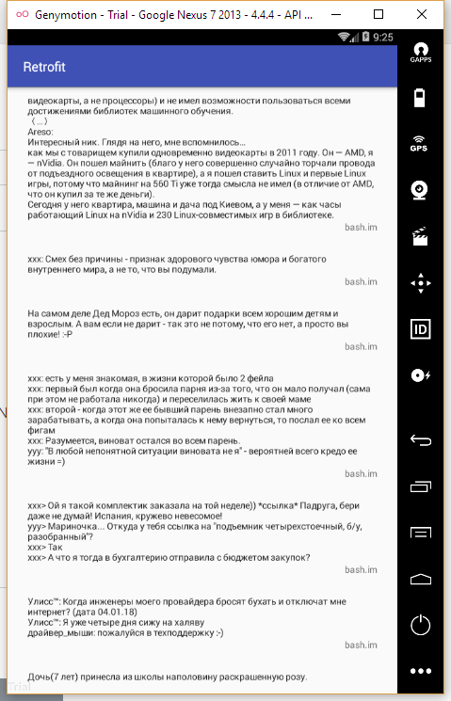

Исходный код.

MainActivity.java:

1. **package** ru.verkhoumov.retrofit;
3. **import** android.support.v7.app.AppCompatActivity;
4. **import** android.os.Bundle;
5. **import** android.support.v7.widget.LinearLayoutManager;
6. **import** android.support.v7.widget.RecyclerView;
7. **import** android.widget.Toast;
9. **import** java.util.ArrayList;
10. **import** java.util.List;
12. **import** retrofit2.Call;
13. **import** retrofit2.Callback;
14. **import** retrofit2.Response;
16. **public** **class** MainActivity **extends** AppCompatActivity {
17. RecyclerView recyclerView;
18. List<PostModel> posts;
20. @Override
21. **protected** **void** onCreate(Bundle savedInstanceState) {
22. **super**.onCreate(savedInstanceState);
23. setContentView(R.layout.activity_main);
25. posts = **new** ArrayList<>();
27. LinearLayoutManager layoutManager = **new** LinearLayoutManager(**this**);
28. recyclerView = (RecyclerView) findViewById(R.id.posts_recycle_view);
29. recyclerView.setLayoutManager(layoutManager);
31. PostsAdapter adapter = **new** PostsAdapter(posts);
32. recyclerView.setAdapter(adapter);
34. App.getApi().getData("bash", 10).enqueue(**new** Callback<List<PostModel>>() {
35. @Override
36. **public** **void** onResponse(Call<List<PostModel>> call, Response<List<PostModel>> response) {
37. posts.addAll(response.body());
38. recyclerView.getAdapter().notifyDataSetChanged();
39. }
41. @Override
42. **public** **void** onFailure(Call<List<PostModel>> call, Throwable t) {
43. Toast
44. .makeText(MainActivity.**this**, "Connecting failed", Toast.LENGTH_LONG)
45. .show();
47. t.printStackTrace();
48. }
49. });
50. }
51. }

PostsAdapter.java:

1. **package** ru.verkhoumov.retrofit;
3. **import** android.os.Build;
4. **import** android.support.v7.widget.RecyclerView;
5. **import** android.text.Html;
6. **import** android.view.LayoutInflater;
7. **import** android.view.View;
8. **import** android.view.ViewGroup;
9. **import** android.widget.TextView;
11. **import** java.util.List;
13. **public** **class** PostsAdapter **extends** RecyclerView.Adapter<PostsAdapter.ViewHolder> {
14. **private** List<PostModel> posts;
16. **public** PostsAdapter(List<PostModel> posts) {
17. **this**.posts = posts;
18. }
20. @Override
21. **public** ViewHolder onCreateViewHolder(ViewGroup parent, **int** viewType) {
22. View v = LayoutInflater.from(parent.getContext()).inflate(R.layout.post_item, parent, **false**);
24. **return** **new** ViewHolder(v);
25. }
27. @Override
28. **public** **void** onBindViewHolder(ViewHolder holder, **int** position) {
29. PostModel post = posts.get(position);
31. **if** (Build.VERSION.SDK_INT >= Build.VERSION_CODES.N) {
32. holder.post.setText(Html.fromHtml(post.getElementPureHtml(), Html.FROM_HTML_MODE_LEGACY));
33. } **else** {
34. holder.post.setText(Html.fromHtml(post.getElementPureHtml()));
35. }
37. holder.site.setText(post.getSite());
38. }
40. @Override
41. **public** **int** getItemCount() {
42. **if** (posts == **null**) {
43. **return** 0;
44. }
46. **return** posts.size();
47. }
49. **class** ViewHolder **extends** RecyclerView.ViewHolder {
50. TextView post;
51. TextView site;
53. **public** ViewHolder(View itemView) {
54. **super**(itemView);
56. post = (TextView) itemView.findViewById(R.id.postitem_post);
57. site = (TextView) itemView.findViewById(R.id.postitem_site);
58. }
59. }
60. }

App.java:

1. **package** ru.verkhoumov.retrofit;
3. **import** android.app.Application;
5. **import** retrofit2.Retrofit;
6. **import** retrofit2.converter.gson.GsonConverterFactory;
8. **public** **class** App **extends** Application {
9. **private** **static** ApiInterface apiInterface;
10. **private** Retrofit retrofit;
12. @Override
13. **public** **void** onCreate() {
14. **super**.onCreate();
16. retrofit = **new** Retrofit.Builder()
17. *// Основная часть адреса.*
18. .baseUrl("http://umorili.herokuapp.com/")
19. *// Конвертер для преобразования JSON-данных в объекты.*
20. .addConverterFactory(GsonConverterFactory.create())
21. .build();
23. *// Объект для выполнения запросов к API.*
24. apiInterface = retrofit.create(ApiInterface.**class**);
25. }
27. **public** **static** ApiInterface getApi() {
28. **return** apiInterface;
29. }
30. }

ApiInterface.java:

1. **package** ru.verkhoumov.retrofit;
3. **import** java.util.List;
5. **import** retrofit2.Call;
6. **import** retrofit2.http.GET;
7. **import** retrofit2.http.Query;
9. **public** **interface** ApiInterface {
10. @GET("/api/get")
11. Call<List<PostModel>> getData(@Query("name") String resourceName, @Query("num") **int** count);
12. }

build.gradle (app):

1. apply plugin: 'com.android.application'
3. android {
4. compileSdkVersion 24
5. buildToolsVersion "27.0.3"
7. defaultConfig {
8. applicationId "ru.verkhoumov.retrofit"
9. minSdkVersion 19
10. targetSdkVersion 24
11. versionCode 1
12. versionName "1.0"
13. }
14. buildTypes {
15. release {
16. minifyEnabled **false**
17. proguardFiles getDefaultProguardFile('proguard-android.txt'), 'proguard-rules.pro'
18. }
19. }
20. }
22. dependencies {
23. compile fileTree(dir: 'libs', include: ['*.jar'])
24. testCompile 'junit:junit:4.12'
25. compile 'com.android.support:appcompat-v7:25.3.1'
26. compile 'com.squareup.retrofit2:retrofit:2.1.0'
27. compile 'com.squareup.retrofit2:converter-gson:2.1.0'
28. compile 'com.android.support:recyclerview-v7:25.3.1'
29. }

activity_main.xml:

1. **<?xml** version="1.0" encoding="utf-8"**?>**
2. **<RelativeLayout** xmlns:android="http://schemas.android.com/apk/res/android"
3. xmlns:tools="http://schemas.android.com/tools"
4. android:id="@+id/activity_main"
5. android:layout_width="match_parent"
6. android:layout_height="match_parent"
7. android:paddingBottom="@dimen/activity_vertical_margin"
8. android:paddingLeft="@dimen/activity_horizontal_margin"
9. android:paddingRight="@dimen/activity_horizontal_margin"
10. android:paddingTop="@dimen/activity_vertical_margin"
11. tools:context="ru.verkhoumov.retrofit.MainActivity"**>**
13. **<android.support.v7.widget.RecyclerView**
14. android:layout_width="match_parent"
15. android:layout_height="match_parent"
16. android:layout_alignParentTop="true"
17. android:layout_alignParentStart="true"
18. android:id="@+id/posts_recycle_view" **/>**
19. **</RelativeLayout>**

post_item.xml:

1. **<?xml** version="1.0" encoding="utf-8"**?>**
2. **<RelativeLayout**
3. xmlns:android="http://schemas.android.com/apk/res/android"
4. android:layout_width="match_parent"
5. android:layout_height="wrap_content"
6. android:padding="15dp"**>**
8. **<TextView**
9. android:id="@+id/postitem_post"
10. android:layout_width="match_parent"
11. android:layout_height="wrap_content"
12. android:text="Post"
13. android:textColor="?android:attr/textColorPrimary"
14. android:layout_alignParentTop="true"
15. android:layout_alignParentStart="true" **/>**
17. **<TextView**
18. android:id="@+id/postitem_site"
19. android:layout_width="wrap_content"
20. android:layout_height="wrap_content"
21. android:text="Bash.im"
22. android:textAlignment="textEnd"
23. android:layout_below="@+id/postitem_post"
24. android:layout_alignParentEnd="true"
25. android:gravity="end" **/>**
26. **</RelativeLayout>**